
Dashboard Design

Date | 1 November2026
Team ID
Project Name | Electric Vehicle Market Performance & insights
Maximum Marks | 5 Marks

Creating an effective dashboard involves thoughtful design to ensure that the presented information is clear, relevant, and easily understandable for the intended audience. Here are some key principles and best practices for dashboard design
Activity 1: Interactive and visually appealing dashboards
Creating interactive and visually appealing dashboards involves a combination of thoughtful design, effective use of visual elements, and the incorporation of interactive features. Here are some tips to help you design dashboards that are both visually appealing and engaging for users so take care of below points
- Clear and Intuitive Layout
- Use Appropriate Visualizations
- Colour and Theming
- Interactive Filters and Slicers
- Drill-Down Capabilities
- Responsive Design
- Custom Visuals and Icons
- Use of Infographics

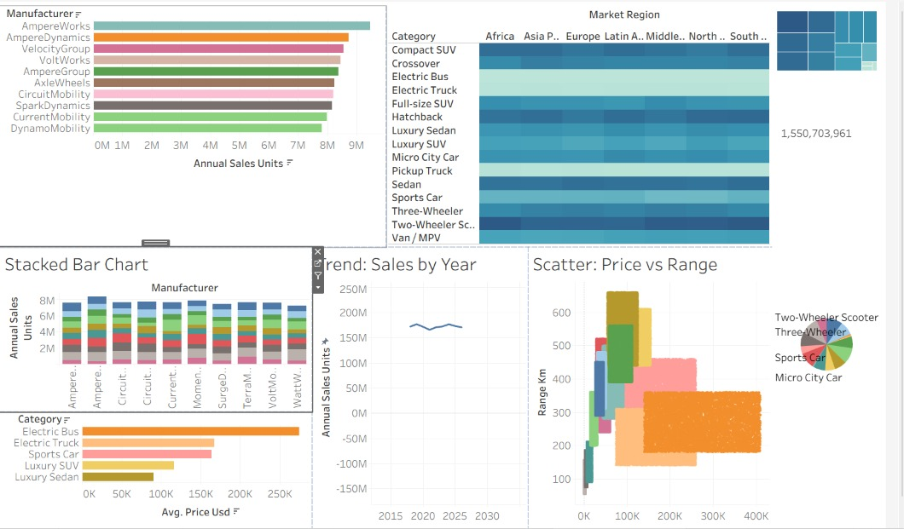
- Major Outcomes from the EV Market Dashboard
- Overall Market Performance: The dashboard reports total EV sales of 1.55B units, an average vehicle price of $64,921, an average driving range of 324.54 km, and 738K tons of CO₂ saved annually.
- Production Leaders: India, China, and Vietnam are among the leading countries in EV production output.
- Manufacturer Performance: AmpereWorks and AmpereDynamics show strong annual sales performance.
- Vehicle Categories: Electric Buses, Electric Trucks, and Luxury SUVs show significant market contributions.
- Driving Range: Luxury Sedans and Luxury SUVs offer longer driving ranges, approximately 550–600 km.
- Battery Technology: NMC and LFP are important battery technologies represented in the dashboard.
- Environmental Impact: The dashboard highlights CO₂ savings and regional environmental performance.
- Business Insights: Interactive visualizations help compare manufacturers, analyze pricing, and identify EV market opportunities.

Activity 2
Publish Dashboard on Tableau Public and Paste the Dashboard Public link below:
Example: https://public.tableau.com/app/profile/soumil.jaiswal/viz/ev_market_performance/ev_market_dashboard?publish=yes

